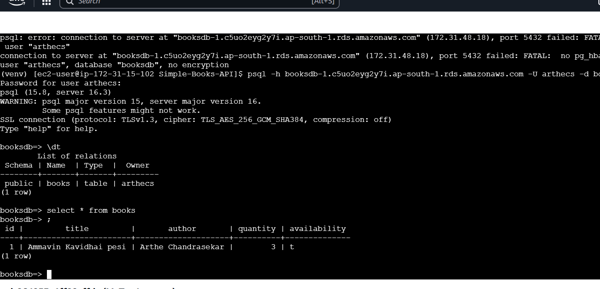

EC2 Instance result

<http://65.1.134.174:8080/docs-> fastAPI testing endpoint